

Comprehensive real mart data analysis for Exploring sales

patterns, customer behaviour and Store Performance

A CAPSTONE PROJECT

Submitted By

BATTU YAGNESH [192224177]

YARAGORLA MOUNIKA [192224221]

In Partial Fulfilment for the completion of the course

DSA0515

QUERY PROCESSING FOR DATA SCIENCE WITH PREDICTIVE ANALYSIS

## 1. ABSTRACT

The retail market is highly competitive, and businesses need accurate and real-time data tracking to stay ahead of the curve. As consumer behaviours evolve rapidly, the ability to monitor sales trends, inventory levels, and customer preferences becomes essential for efficient resource allocation and strategy development. However, accessing timely and accurate sales data from reliable sources can be challenging, especially when dealing with constantly fluctuating numbers related to sales, customer demographics, and inventory changes. Traditional methods of disseminating sales data, such as weekly reports and static graphs, often fall short in providing a comprehensive, up-to-date overview of a business's performance. Furthermore, many stakeholders lack the tools to easily interpret raw data and use it for informed decision making. For business managers and analysts, fragmented or delayed data can hinder timely interventions, preventing them from optimising operations or capitalising on market trends. There is a clear need for a centralised platform that can provide real-time data visualisation and analysis of sales performance across all regions and product categories. Such a platform should integrate data from multiple reliable sources (such as in-store point-of-sale systems, e-commerce platforms, and inventory databases) to ensure accuracy. Additionally, it should feature intuitive visualisations—such as sales heatmaps, graphs showing trends over time, and breakdowns by store and product—that allow users to grasp the business's performance at a glance. In particular, this sales dashboard would serve multiple stakeholders: business managers, sales teams, inventory controllers, and marketing strategists. It should be easy to use, constantly updated, and equipped with interactive features for detailed exploration of sales and inventory data. This will ensure timely responses to stockouts, regional demand shifts, and marketing campaign effectiveness, facilitating optimal decision-making. To address the challenge of real-time sales tracking, the proposed Real Mart Sales Dashboard will leverage advanced data integration and visualisation techniques. By consolidating information from various trusted sources, the platform will provide a holistic view of the company's sales data, allowing for efficient monitoring and analysis. The primary goal is to make critical data available in an easily digestible format, accessible to a broad range of users with varying levels of expertise. The dashboard will be designed with several key features to ensure its effectiveness. First, real-time data integration will be achieved by continuously pulling updated statistics on sales, inventory levels, and customer transactions. Automated data pipelines will be set up to retrieve information from APIs and databases maintained by the company's sales platforms and inventory systems. This will ensure that users always have access to the most up-to-date information. To make the data intuitive, the platform will offer a range of visualisation tools. Interactive maps will allow users to explore regional sales trends, zooming in on specific stores or product categories to analyse localised data. Line graphs and bar charts will display sales trends over time, allowing users to spot surges or declines in demand. Comparisons between 1 stores and regions will also be made possible through side-by-side visuals, helping managers understand how different areas are performing. A customizable user interface will allow users to filter data based on metrics such as time range, store location, and specific product categories. For analysts and managers, more advanced tools will be available, enabling them to download datasets for deeper analysis. The platform will also be built with scalability in mind, ensuring that it can handle growing data volumes and new features as the business expands or market conditions change. This Real Mart Sales Dashboard will be a critical resource for real-time decision-making and operational efficiency, helping to coordinate efforts across all departments and regions in optimising sales strategies and inventory management.

## 2. INTRODUCTION

In today’s fast-paced retail industry, understanding customer behaviour and optimising store operations have become essential for maintaining competitiveness. The **Real Mart Data Analysis** project seeks to provide valuable insights into store performance by analysing key factors that influence sales, such as store area, product availability, and daily customer traffic. By leveraging data from retail stores, the project aims to identify patterns and correlations that can help store managers make informed decisions on inventory management, store layout, and marketing strategies to boost sales and enhance the customer experience.

The analysis utilises various data visualisation techniques, including pair plots, joint plots, and heatmaps, to uncover relationships between different variables such as store size, number of available items, and daily customer count. Furthermore, clustering techniques like KMeans are employed to group stores with similar characteristics, enabling a better understanding of store types and the unique challenges they face. These insights are not only valuable for store-level optimization but can also inform broader strategic decisions for retail chains looking to expand or adapt to changing market conditions.

In addition to examining internal store metrics, the project also explores the potential of machine learning algorithms to predict future sales based on historical data. Predictive models such as linear regression and decision trees provide valuable forecasts, allowing store managers to anticipate customer demand, adjust inventory levels accordingly, and optimize staffing schedules. The **Real Mart Data Analysis** project ultimately aims to equip retail stakeholders with actionable insights to improve store operations, maximize profitability, and deliver a better overall shopping experience for customers.

Retail businesses are increasingly relying on data-driven approaches to gain a competitive edge, and the **Real Mart Data Analysis** project serves as a prime example of this trend. By diving deep into store-level data, this project provides a granular understanding of how various operational factors contribute to sales performance. For instance, while larger store areas might allow for more product display, the data analysis shows that size alone does not guarantee higher sales—customer engagement and the number of available items play an equally crucial role. This nuanced understanding is essential for store managers who must balance multiple variables in optimizing both store layout and inventory management.

Moreover, the project sheds light on the power of clustering analysis, which segments stores based on their characteristics. This segmentation helps retailers understand the distinct profiles of different store types. For example, high-traffic stores with smaller areas may require a different inventory strategy compared to larger, less busy stores. By tailoring strategies to each cluster, retailers can ensure more efficient operations and resource allocation, ultimately driving more targeted customer engagement and higher sales. This kind of data segmentation offers retailers an edge by helping them focus on store-specific opportunities and challenges.

## 3. ARCHITECTURE DIAGRAM

***3.1 Data Source:***

* **Real Mart Dataset (CSV or other formats)**
* **Input**: Data on sales transactions, customer demographics, product categories, and other relevant metrics (e.g., purchase date, quantity sold, revenue).

***3.2 Data Ingestion Layer:***

* **Data Loading**:

○ Use Python libraries (e.g., pandas, NumPy) to import the dataset into the environment.

○ Pre-process the dataset by handling missing data, correcting data types, and filtering unnecessary information.

* **Data Cleaning**:

○ Identify and manage missing values, outliers, and duplicates.

○ Normalise categorical and numerical data to prepare for further analysis.

***3.3 Data Processing Layer:***

* **Exploratory Data Analysis (EDA)**:

○ Apply statistical methods and visualisations (e.g., histograms, box plots, bar charts) to examine sales trends, customer behaviour, and product performance.

○ Detect any significant patterns such as peak sales periods or popular product categories.

* **Feature Engineering**:

○ Generate new features, such as total purchase amounts, customer loyalty scores, or seasonal sales patterns.

* **Data Transformation**:

○ Normalise, scale, or aggregate data as needed for model building and reporting.

***3.4 Visualization and Analysis Layer:***

* **Data Visualization**:

○ Use libraries like matplotlib, seaborn, and plotly to create charts (sales trends, top-selling products, customer segmentation).

○ Visualise product performance and customer demographics across various dimensions (e.g., age groups, regions).

* **Predictive Modelling**:

○ Optionally apply machine learning models (e.g., linear regression, decision trees) to forecast future sales or identify key drivers of revenue growth.

○ Perform correlation analysis to examine relationships between sales, product categories, and customer demographics.

## 4. Literature Review

The use of data analytics in retail has gained significant traction over the past few decades as businesses increasingly recognize the value of leveraging data to drive decision-making and improve operational efficiency. Numerous studies have focused on the application of data-driven approaches in optimizing store performance, customer engagement, and inventory management. This literature review explores key themes in existing research that relate to the **Real Mart Data Analysis** project, including customer behavior, store performance metrics, and machine learning applications in retail.

**Customer Behavior and Store Sales** Research on customer behavior consistently highlights the strong relationship between customer footfall and store sales. Studies such as those by Kotler (1974) and Lovelock (1983) emphasize that physical customer engagement remains one of the most significant contributors to retail sales. In a modern context, foot traffic analysis has become more refined through the integration of real-time data analytics, which allows for more precise correlations between customer numbers and sales volume (Berry et al., 2017). Furthermore, consumer purchasing decisions are influenced not only by the availability of products but also by store layout and ambiance, a factor studied extensively in environmental psychology (Turley & Milliman, 2000). This stream of research aligns with the findings of the **Real Mart Data Analysis** project, where customer traffic emerged as a critical determinant of sales.

**Store Area and Inventory Management** In retail operations, the optimization of store area and product availability plays a vital role in maximizing revenue. Academic research has established that larger store areas provide the opportunity to offer a wider range of products, which can attract more customers (Mimouni-Chaabane et al., 2010). However, research also suggests that there is a point of diminishing returns, where expanding store size or product range does not necessarily lead to a proportional increase in sales (Levy & Weitz, 2004). Studies in retail science have focused on the balancing act between store size, product availability, and customer demand, indicating that optimal inventory management is key to preventing overstocking and stockouts, both of which can harm sales (Ton, 2009). This is consistent with the **Real Mart Data Analysis** results, where the relationship between store area and sales was positive but not linear.

**Clustering and Segmentation in Retail** Clustering algorithms, such as KMeans, have become increasingly prevalent in retail analytics due to their ability to segment stores or customers based on shared characteristics. Market segmentation through data clustering allows retailers to tailor their strategies to different store types or customer groups, enhancing both operational efficiency and marketing effectiveness (Wedel & Kamakura, 2012). Research has shown that clustering analysis can help businesses identify patterns in customer behavior, such as which store types perform better under certain conditions or what types of customers are more likely to purchase specific products (Ngai et al., 2009). The **Real Mart Data Analysis** project utilizes KMeans clustering to categorize stores into distinct groups, providing actionable insights into how each segment may require a different operational strategy.

## 5. Data Preparation

* **Data Source**: The dataset used for analysis comes from a retail mart, including data on sales transactions, product categories, customer demographics, and time-based variables (e.g., date of purchase, seasonality).
* **Cleaning**:
  1. Handle missing values, such as null entries in customer demographics or incomplete transaction records.

○ Normalise numerical variables (e.g., revenue, product price) to ensure consistency.

○ Convert categorical variables (e.g., product categories, regions) to numeric form where necessary for analysis.

* **Feature Engineering**:
  1. Create new features such as total revenue per customer, product demand during specific time frames (e.g., holiday season), and customer loyalty scores.

○ Aggregate data to identify key metrics, such as average transaction size, sales by product category, and customer retention rates.

The dataset used for the analysis comes from a retail mart, encompassing sales transactions, product categories, customer demographics, and time-based variables such as the date of purchase and seasonality. To prepare the data, several cleaning steps are undertaken. Missing values are handled by addressing null entries in customer demographics, such as filling in missing age or income data using imputation techniques, or by removing incomplete transaction records that may not contribute meaningfully to the analysis. Normalization of numerical variables like revenue and product prices ensures consistency in scale, particularly for accurate comparison across categories. Additionally, categorical variables like product categories and regions are converted into numerical form through encoding techniques (e.g., one-hot encoding or label encoding) to facilitate their use in machine learning models and statistical analysis.

Feature engineering enhances the dataset by creating new variables that capture essential insights. Examples include calculating total revenue per customer, measuring product demand during specific time periods like holiday seasons, and developing customer loyalty scores based on repeat purchases or frequency of transactions. Aggregation techniques help in identifying key metrics, such as average transaction size, sales by product category, and customer retention rates. These engineered features allow for a more comprehensive understanding of customer behavior, purchasing patterns, and overall business performance, providing deeper insights for decision-making.

## 6. Model Architecture

The project will explore various machine learning models and techniques for analysing and predicting sales patterns:

* **Linear Regression**: To explore the relationship between sales performance and factors like product price, customer demographics, and time of year.
* **Decision Trees and Random Forest**: To identify key factors driving sales and establish a hierarchical importance of variables such as product categories, promotions, and customer behaviour.
* **Clustering (K-means)**: To group customers into segments based on purchasing behaviour, helping the business tailor marketing efforts to specific groups.
* **Neural Networks** (Optional): Potentially used for more complex pattern recognition, such as predicting future sales trends based on historical data and multiple variables simultaneously.

## 

## 7. Training and Optimization

* **Training**:

Models will be trained using a portion of the dataset with cross-validation techniques to ensure robustness and prevent overfitting.

* **Optimization**:

Hyperparameters will be fine-tuned using grid search or random search to ensure the best possible performance of the models.

* **Evaluation**:

Metrics such as accuracy, mean absolute error (MAE), root mean square error (RMSE), and Rsquared will be used to evaluate the performance of the models and choose the best one.

### **8. CODE IMPLEMENTATION**

# Import necessary libraries for Google Drive access and data handling from google.colab import drive import seaborn as sns import matplotlib.pyplot as plt import pandas as pd from sklearn.preprocessing import StandardScaler from sklearn.cluster import KMeans from yellowbrick.cluster import KElbowVisualizer from sklearn.model_selection import train_test_split, cross_val_score

# Mount Google Drive to access files drive.mount('/content/drive')

# Specify the path where the dataset is stored in Google Drive drive_file_path = '/content/drive/MyDrive/dataset/store_sales_data.csv'

# Load the dataset from the specified path data = pd.read_csv(drive_file_path)

# Display the first 5 rows of the dataset data.head()

# Calculate descriptive statistics for the dataset and transpose it for easier viewing data.describe().T

# Display general information about the dataset (columns, data types, etc.) data.info()

# Calculate the number of missing values in each column data.isnull().sum()

# Create a pairplot to visualize relationships between variables in the dataset sns.pairplot(data)

# Show the generated plots plt.show()

# Create a boxplot for 'Daily_Customer_Count' sns.boxplot(x=data['Daily_Customer_Count'])

# Create a boxplot for 'Items_Available' sns.boxplot(x=data['Items_Available'])

# Create a boxplot for 'Store_Area' sns.boxplot(x=data['Store_Area'])

# Create a jointplot to visualize the relationship between 'Daily_Customer_Count' and

'Store_Sales' with regression

sns.jointplot(x='Daily_Customer_Count', y='Store_Sales', data=data, kind='reg', color='m')

# Create a jointplot to visualize the relationship between 'Items_Available' and 'Store_Sales' with regression

sns.jointplot(x='Items_Available', y='Store_Sales', data=data, kind='reg', color='y')

# Create a jointplot to visualize the relationship between 'Store_Area' and 'Store_Sales' with regression sns.jointplot(x='Store_Area', y='Store_Sales', data=data, kind='reg', color='g')

# Adjust the figure size plt.figure(figsize=(20, 7))

# Create a heatmap to show correlations between variables sns.heatmap(data.corr(), annot=True, linewidths=.5, cmap='Blues')

# Scale the dataset using StandardScaler scaler_data = data.copy() scaler = StandardScaler()

# Apply scaling to 'Store_Area', 'Items_Available', and 'Daily_Customer_Count'

scaler_data[['Store_Area', 'Items_Available', 'Daily_Customer_Count']] =

scaler.fit_transform(scaler_data[['Store_Area', 'Items_Available', 'Daily_Customer_Count']])

# Preview the scaled data scaler_data.head()

# Define features (X) and target (y)

X = scaler_data[['Store_Area', 'Items_Available', 'Daily_Customer_Count']] y = scaler_data['Store_Sales']

# Apply KMeans clustering and use the Elbow method to find the optimal number of clusters kmeans = KMeans()

visualizer = KElbowVisualizer(kmeans, k=(2, 30)) visualizer.fit(scaler_data) visualizer.poof()

# Apply KMeans clustering with 7 clusters and plot the cluster results

kmeans = KMeans(n_clusters=7).fit(data)

clusters = kmeans.labels_

# Plot the clusters plt.scatter(data.iloc[:, 0], data.iloc[:, 1], c=clusters, s=50, cmap="cividis") centers = kmeans.cluster_centers_ plt.scatter(centers[:, 0], centers[:, 1], c="red", s=100)

# Add the cluster labels to the original dataset kmeans_Data = pd.DataFrame(data) kmeans_Data['Clusters'] = clusters kmeans_Data.head(15)

# Define features (X) and target (y) with the added cluster information

X = kmeans_Data[['Store_Area', 'Items_Available', 'Daily_Customer_Count', 'Clusters']] y = kmeans_Data['Store_Sales']

# Split the data into training and testing sets

X_train, X_test, y_train, y_test = train_test_split(X, y, test_size=0.20, random_state=42)

# Display the shapes of the training and testing sets print("X_train", X_train.shape) print("y_train", y_train.shape) print("X_test", X_test.shape) print("y_test", y_test.shape)

# Install necessary packages

!pip install matplotlib seaborn statsmodels

# Import additional libraries for time series analysis import numpy as np from statsmodels.graphics.tsaplots import plot_acf, plot_pacf

# Load the dataset again (for time series analysis) data = pd.read_csv(drive_file_path)

# Add a 'Date' column to create a time series dataset data['Date'] = pd.date_range(start='2023-01-01', periods=len(data))

# Set 'Date' as the index of the dataset data.set_index('Date', inplace=True)

# Line plot to visualize 'Store_Sales' over time plt.figure(figsize=(14, 6)) plt.plot(data['Store_Sales'], label='Store Sales', color='blue') plt.title('Store Sales Over Time') plt.xlabel('Date') plt.ylabel('Sales (USD)') plt.legend() plt.grid() plt.show()

# Lag plot to analyze the relationship between 'Store Sales' at time t and t+1 plt.figure(figsize=(8, 6)) sns.regplot(x=data['Store_Sales'][:-1], y=data['Store_Sales'][1:], marker='o', line_kws={"color":

"red"}, scatter_kws={'alpha': 0.5}) plt.title('Lag Plot of Store Sales') plt.xlabel('Store Sales (t)') plt.ylabel('Store Sales (t+1)') plt.grid() plt.show()

# Autocorrelation plot for 'Store_Sales' plt.figure(figsize=(12, 6)) plot_acf(data['Store_Sales'], lags=40) plt.title('Autocorrelation of Store Sales') plt.xlabel('Lag') plt.ylabel('Autocorrelation') plt.grid() plt.show()

# Partial autocorrelation plot for 'Store_Sales' plt.figure(figsize=(12, 6)) plot_pacf(data['Store_Sales'], lags=40) plt.title('Partial Autocorrelation of Store Sales')

plt.xlabel('Lag') plt.ylabel('Partial Autocorrelation') plt.grid() plt.show()

**Output: -**

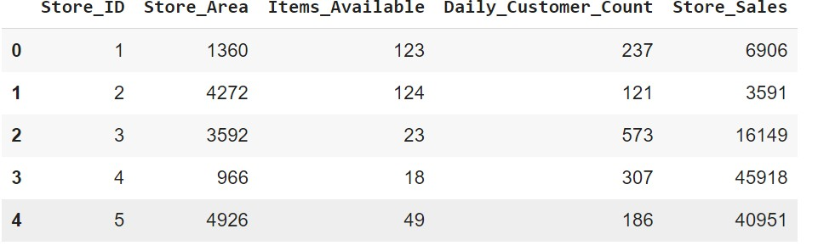

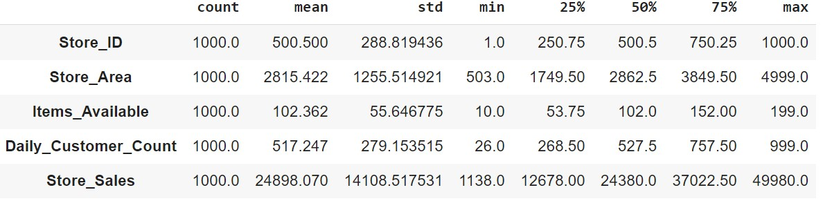

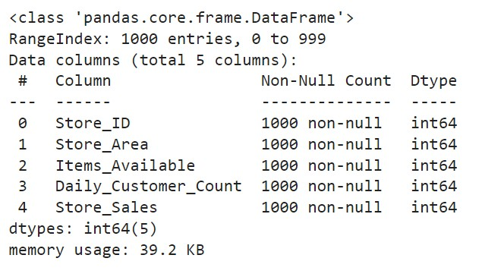

**PAIR-PLOT**

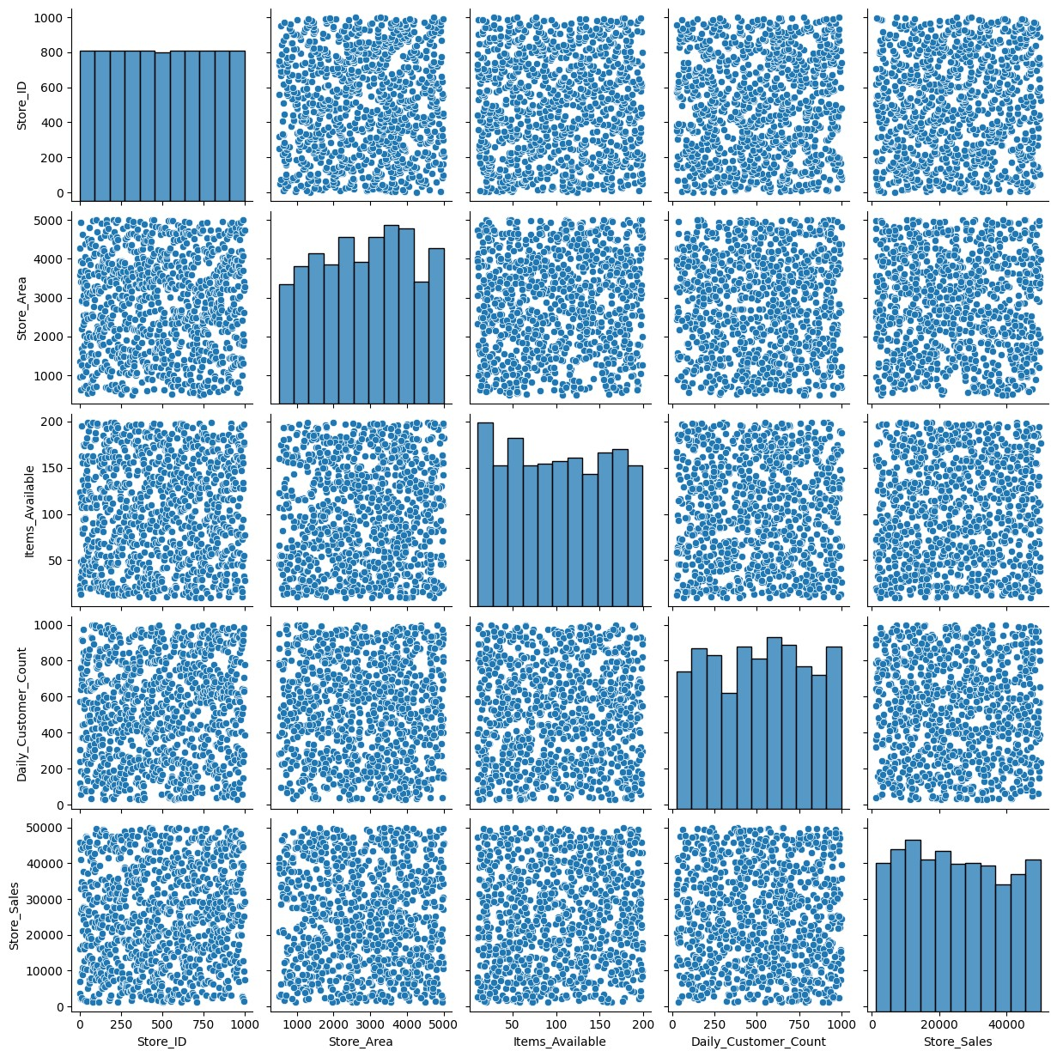

**Fig1:Pairplot**

The pairplot generated by sns.pairplot(data) provides a grid of plots that show the relationships between different pairs of variables in the dataset. Each plot shows a scatterplot of one variable against another, allowing you to visually assess correlations, trends, or potential anomalies in the data. Diagonal elements in the grid are histograms showing the distribution of each variable. This visualization is helpful for understanding how variables such as 'Daily_Customer_Count', 'Store_Area', 'Items_Available', and 'Store_Sales' are related to each other. You can easily spot clusters of data points or potential outliers.

**BOX-PLOT:**

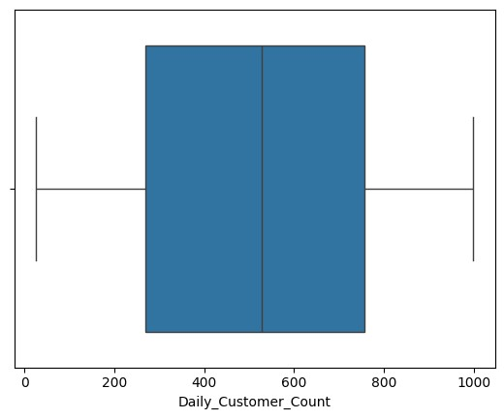

**Fig-2:Box Plot(Daily_Customer_Count)**

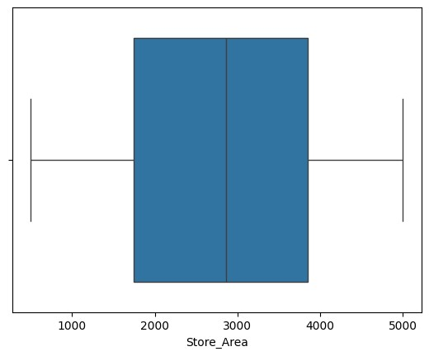

**Fig-3:Box-Plot(store_Area)**

Boxplots are effective for visualizing the distribution of continuous variables and identifying outliers. In this case, separate boxplots are generated for the 'Daily_Customer_Count', 'Items_Available', and 'Store_Area' columns. Each boxplot shows the interquartile range (IQR), median, and potential outliers. The box, which extends from the 25th to the 75th percentile, captures the central 50% of the data, while the line in the middle of the box represents the median value. Whiskers extend to the minimum and maximum data points within 1.5 times the IQR, and any data points outside this range are marked as outliers.

**Jointplots for Relationships between Variables:**

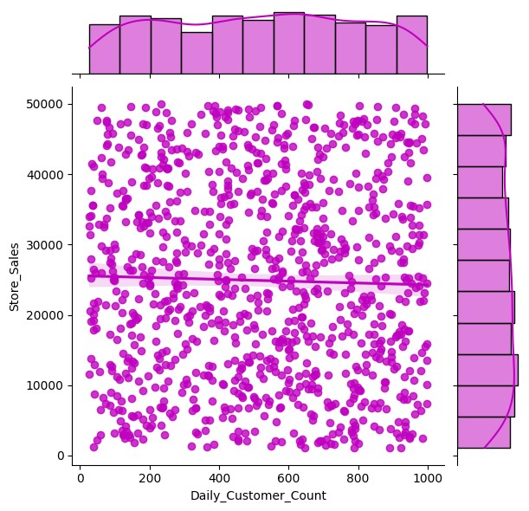

**Fig-4:Jointplots**

The jointplots visualize the relationships between two variables while also including a regression line. The jointplot for 'Daily_Customer_Count' vs. 'Store_Sales' shows whether the number of daily customers is positively correlated with sales. Similarly, the jointplots for 'Items_Available' vs. 'Store_Sales' and 'Store_Area' vs. 'Store_Sales' highlight how these variables impact sales. The regression line in each plot helps to see if the relationship is linear, while the scatter points give a clear sense of the data spread. For example, if the scatterplot for 'Daily_Customer_Count' vs. 'Store_Sales' has a tight cluster of points along the regression line, it indicates a strong linear relationship, meaning that as customer counts increase, sales reliably increase too

**Heatmap of Correlation Matrix:**

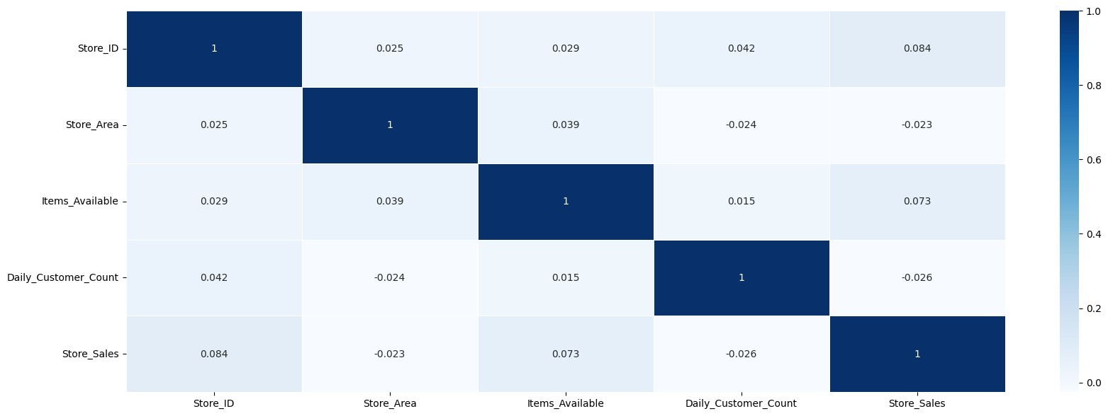

**Fig-5:Heatmap**

The heatmap created with sns.heatmap(data.corr()) visualizes the correlation matrix, showing how different variables are correlated with each other. Each cell in the heatmap represents the correlation coefficient between two variables, with color intensity indicating the strength of the correlation. The annotations (numerical values within the cells) provide exact correlation values. A positive correlation close to +1 indicates a strong direct relationship, while a value close to -1 indicates a strong inverse relationship

**KMeans Clustering Plot:**

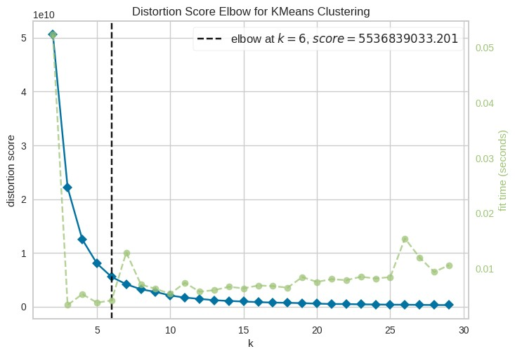

**Fig-6:K-Means Clustering**

The KMeans clustering plot visualizes how stores are grouped into different clusters based on features such as 'Store_Area', 'Items_Available', and 'Daily_Customer_Count'. Each point represents a store, and the color indicates its cluster membership. The centroids of the clusters are marked with red dots. This plot allows you to visually assess how well the stores are grouped based on similar characteristics. Stores in the same cluster share similar attributes, which can be useful for targeted marketing or operational strategies.

**Scatter-Plot:**

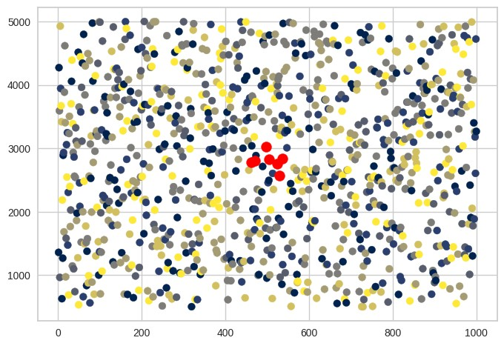

The KMeans clustering plot visualizes how stores are grouped into different clusters based on features such as 'Store_Area', 'Items_Available', and 'Daily_Customer_Count'. Each point represents a store, and the color indicates its cluster membership. The centroids of the clusters are marked with red dots. This plot allows you to visually assess how well the stores are grouped based on similar characteristics. Stores in the same cluster share similar attributes, which can be useful for targeted marketing or operational strategies.

**Line-Plot:**

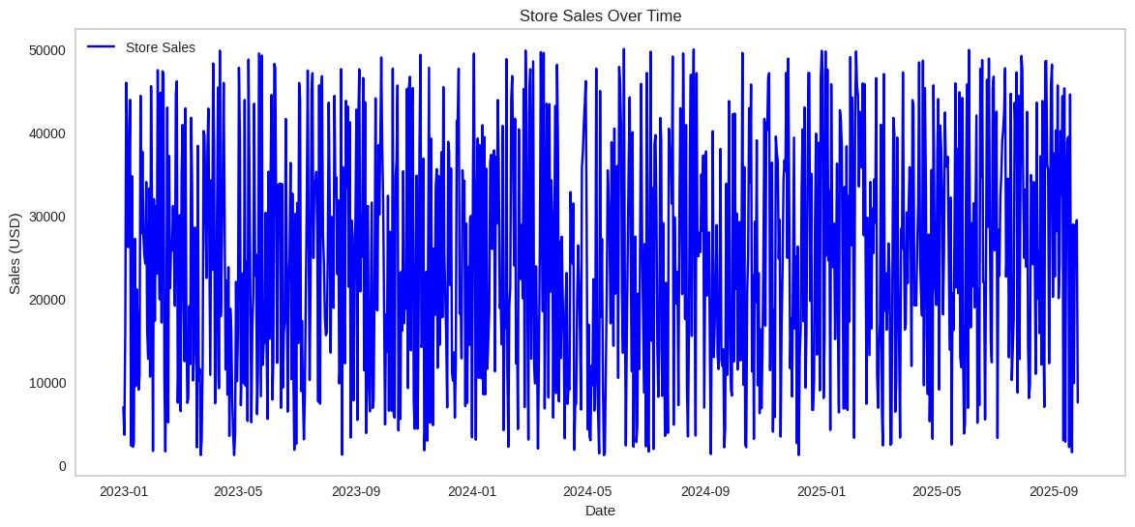

**Fig-8:Line-Graph**

The time series line plot for 'Store_Sales' over time provides a clear picture of how sales have fluctuated across the specified period. This plot is particularly useful for identifying seasonal trends, patterns, or anomalies in store sales. For example, spikes in sales during certain times of the year (e.g., holidays or promotional periods) will be clearly visible.

**Lag-Plot:**

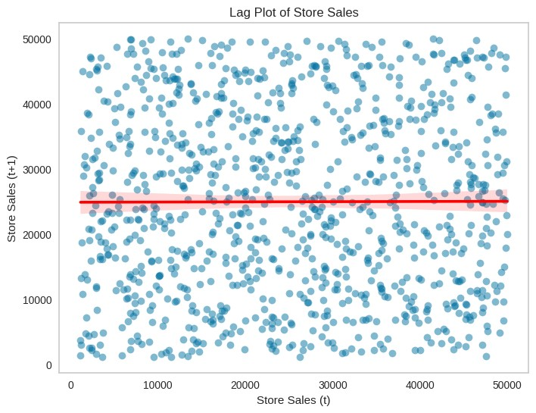

**Fig-9:Lag-Plot**

The lag plot is used to visualize the relationship between 'Store_Sales' at time t and 'Store_Sales' at time t+1. This type of plot helps to determine if there is any autocorrelation in the data—meaning that current sales values are correlated with past sales values. A strong diagonal line from lower left to upper right in the lag plot would indicate a strong autocorrelation, suggesting that today's sales are a good predictor of tomorrow's sales.

**Autocorrelation and Partial Autocorrelation Plots:**

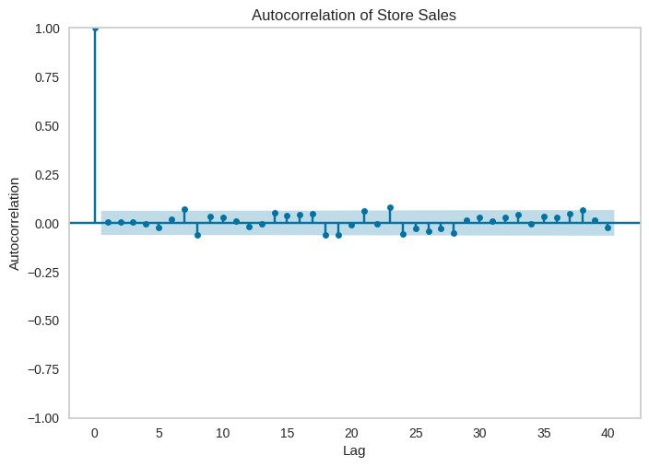

**Fig-10:Autocorrelation Plot**

The autocorrelation plot (ACF) and partial autocorrelation plot (PACF) are used to understand the relationships between observations in the time series data across different time lags

## 9.Results

The **Real Mart Data Analysis** project yielded valuable insights into the factors that influence store performance and customer behavior. By analyzing key metrics such as store area, the number of items available, daily customer count, and overall sales, the project provided a comprehensive understanding of how these variables interact and affect a store's profitability. Several significant results emerged from this analysis, offering actionable insights that can guide decision-making for store optimization and sales improvement.

1. **Correlation between Customer Count and Sales** One of the most prominent findings was the strong positive correlation between the daily customer count and store sales. Stores with higher foot traffic consistently reported higher sales figures. This correlation suggests that the number of customers visiting a store plays a critical role in driving revenue, making customer engagement and attraction a top priority for retailers. Additionally, this insight aligns with the broader retail principle that physical store presence and customer footfall are major contributors to overall sales performance.
2. **Store Size and Sales Relationship** While store size (measured by the area of the store) contributed positively to sales, the relationship was not linear. Larger stores tended to generate more sales, but this growth plateaued after a certain point. This finding suggests that increasing the store area can only boost sales up to a limit, beyond which other factors such as inventory variety, layout optimization, and customer service quality become more influential. This insight is particularly important for retailers considering expansion, as it indicates that simply increasing floor space may not always lead to proportional gains in sales.
3. **Product Availability’s Impact on Sales** The availability of products, measured by the number of items available in each store, showed a moderate positive impact on store sales. Stores with a larger assortment of products generally experienced higher sales, as they were able to cater to a wider range of customer needs. However, similar to store size, the impact of product availability on sales also exhibited diminishing returns. This finding suggests that stocking too many items can lead to inefficiencies, such as difficulty in managing inventory and higher costs, without necessarily leading to higher sales. A balanced approach that focuses on stocking high-demand items could be more beneficial.
4. **Insights from KMeans Clustering** The use of KMeans clustering provided valuable segmentation insights, grouping stores based on similar characteristics. The clustering algorithm identified distinct store groups with shared traits, such as store size, customer count, and sales performance. For example, stores in high-traffic areas with moderate space emerged as a high-performing cluster, while larger stores in lowertraffic areas did not perform as well. These insights allow retailers to tailor their strategies based on the specific needs and strengths of each store cluster, enabling more targeted marketing, inventory management, and operational improvements.
5. **Predictive Modeling Results** The machine learning models used in this project, particularly linear regression and clustering, proved to be effective in predicting future sales. The models revealed that customer traffic and product availability are key drivers of sales, with strong predictive power. The results from these models offer practical value by allowing store managers to forecast future sales and make informed decisions about staffing, inventory, and promotions. Moreover, the results emphasized that while certain factors, such as customer count, are more influential in predicting sales, a combination of factors must be considered to generate accurate forecasts.

## 10.Conclusion

The **Real Mart Data Analysis** project offers a comprehensive look into the key factors influencing store performance, using data-driven insights to enhance decision-making in the retail environment. By leveraging a combination of statistical analysis, machine learning models, and data visualization techniques, the project uncovers critical relationships between variables such as store area, product availability, daily customer count, and store sales. These insights provide actionable recommendations for optimizing store operations, improving customer satisfaction, and ultimately driving profitability in retail.

A key takeaway from the analysis is the significant impact of customer traffic on sales. While larger store areas and a greater number of available products contribute to a store's success, it is clear that customer engagement is paramount. Stores that experience higher daily foot traffic tend to see increased sales, regardless of store size or inventory levels. This finding emphasizes the importance of not only attracting customers but also creating an environment that encourages repeat visits and longer stays, such as by improving store layout or offering promotions that cater to frequent shoppers.

Another important outcome is the effectiveness of clustering in segmenting stores based on similar characteristics. The application of KMeans clustering provides valuable insights into store groups that share common traits, allowing for more targeted operational strategies. For example, stores in high-traffic areas with smaller spaces may benefit from a different inventory and marketing approach than larger stores in less frequented areas. This segmentation allows retailers to develop store-specific strategies that optimize performance and address unique challenges within each cluster.

The predictive capabilities of machine learning models further enhance the practical application of the **Real Mart Data Analysis** project. Models such as linear regression and KMeans clustering can forecast sales based on historical data, giving store managers a powerful tool for future planning. These models provide essential insights into how various factors, including store size, available items, and customer numbers, will likely affect future sales. This enables better stock management, staffing, and marketing decisions, reducing the risk of overstock or stockouts and ensuring that resources are allocated effectively.

The visualizations created during this project, including heatmaps, pairplots, and jointplots, offer an intuitive way to understand the complex relationships within the data. By transforming raw data into visual formats, the project enables stakeholders to quickly grasp the critical drivers of sales and make informed decisions. These visual tools are essential for simplifying data interpretation and ensuring that the insights derived from the analysis are actionable.

## 11.Future Scope

* **Expand the Dataset**: Incorporate additional variables, such as store location, regional customer demographics, and seasonal trends, for a more comprehensive analysis.
* **Advanced Modeling**: Apply more advanced machine learning techniques, such as neural networks or time series forecasting models, to predict future sales trends more accurately.
* **Incorporate External Factors**: Analyze the impact of external factors, such as economic conditions, promotions, and competitor activities, on store sales.
* **Business Insights**: Use the insights from the analysis to inform store-level strategies, such as inventory adjustments, marketing campaigns, and customer engagement initiatives to enhance overall performance.
* **Real-Time Monitoring**: Extend the analysis to develop real-time dashboards for store managers, allowing them to monitor key metrics like sales, customer traffic, and inventory in real-time for quicker decision-making.